|  |  |  |  |
| --- | --- | --- | --- |
| **Course Name:** | **Linear Integrated Circuits and Design** | **Semester:** | **V** |
| **Date of Performance:** | **18/08/2020** | **Batch No:** | **B1** |
| **Faculty Name:** | **Prof. Milind Marathe** | **Roll No:** | **1912052** |
| **Faculty Sign & Date:** |  | **Grade/Marks:** | **/25** |

**Experiment No: 1**

**Title: To implement Subtractor using opamp**

|  |
| --- |
| **Aim and Objective of the Experiment:** |
| To implement Linear equations using op-amp IC 741.   * To design and implement Linear equations using op-amp IC 741. |

|  |
| --- |
| **COs to be achieved:** |
| **CO2:** Design circuits using op-amps as linear applications. |

|  |
| --- |
| **Theory:** |
| The uA741 is used to solve different linear equation.  The linear equation implemented as:  From figure, |

|  |
| --- |
| **Circuit Diagram:** |
|  |

|  |
| --- |
| **Stepwise-Procedure:** |
| 1. Connections are given as per the circuit diagram.  2. + Vcc and - VEE supply is given to the power supply terminal of the Op-Amp IC.  3. Apply input voltages as per requirement.  4. Observe the output voltage obtained on the CRO. |

|  |
| --- |
| **Observation Table:** |
| |  |  |  |  |  | | --- | --- | --- | --- | --- | | **Sr. No.** |  | Va | **Theoretically value** | **Simulated values** | | 1. | 3 | 1 | 2 | 1.9999946V | | 2. | 1 | 3 | -2 | -1.9999946V | | 3. | 5 | 4 | 1 | 0.9999732V | | 4. | 5 | 5 | 0 | 35.90nV | | 5. | 7 | 4 | 3 | 3.9999919V | | 6. | 13 | 1 | 12 | 11.035419V | | 7. | 20 (p-p) Sine | 4 | - | Screenshots attached | | 8. | 10(Sq. Wave) | 5 | - | Screenshots attached | | 9. | 10 Sq | 10 p-p(Sine Wave) | - | Screenshots attached | | 10. | -6 | 6 | -12 | -11.00993V |   **With Different R values**   |  |  |  |  |  | | --- | --- | --- | --- | --- | | **Sr. No.** |  | Va | **Theoretically value** | **Simulated values** | | 1. | 6 | 3 | 1.667V | 1.666V | | 2. | 3 | 3 | 0.333V | 0.333V | | 3. | -4 | 4 | 3.109776V | 3.111V | | 4. | 9 | 6 | 1.999V | 1.999V |   **For Different R** |

|  |
| --- |
| **Calculation:** |
| **Design:-**  …..(1)   1. To design Subtractor,   So that equation 1 becomes  Assume, |

|  |
| --- |
| **Waveforms:** |
| Circuit  All Rs=5ohms |
|  |
|  |

**For Different values of R**

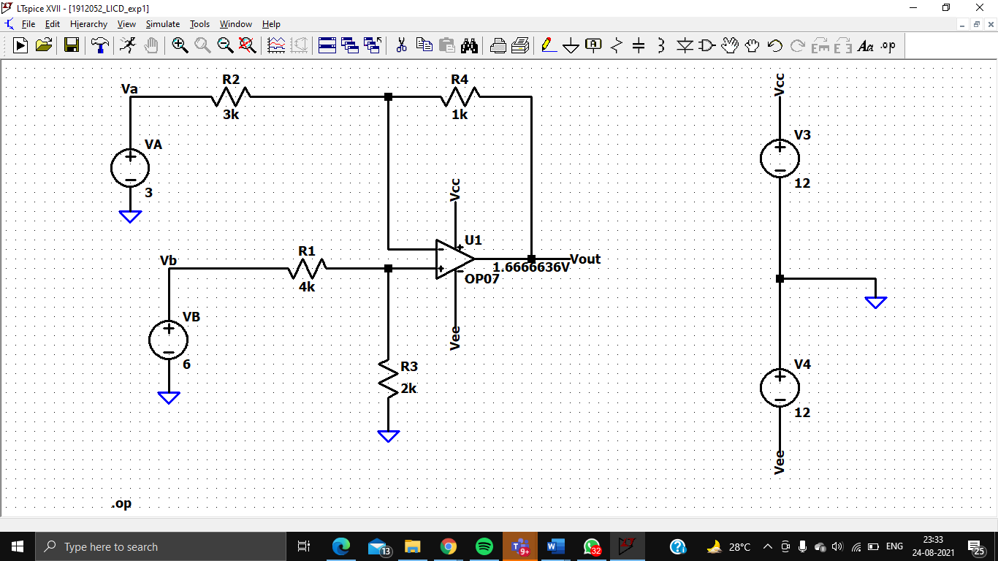

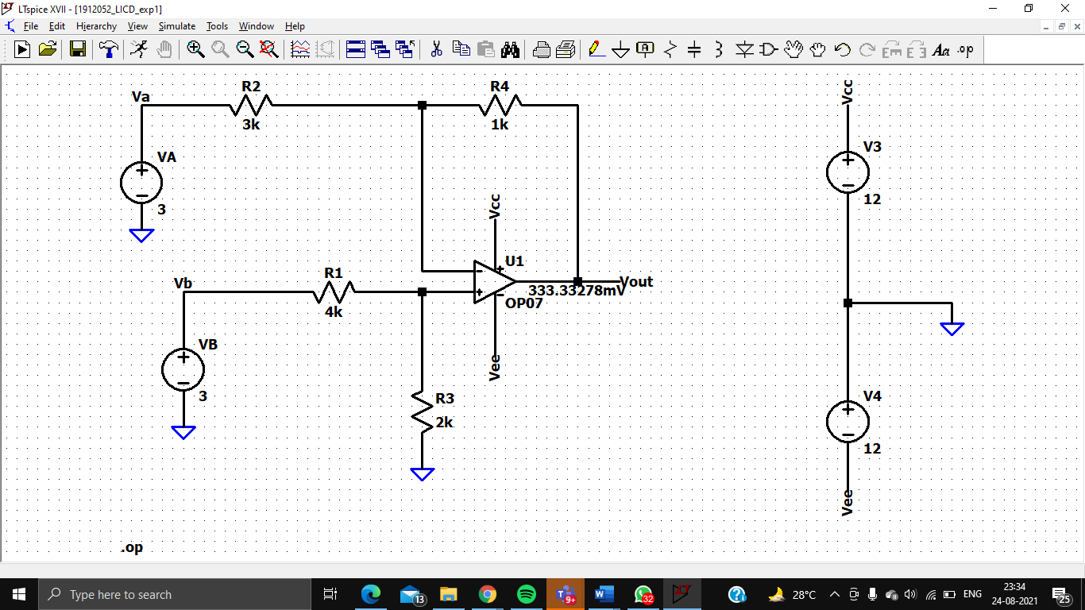

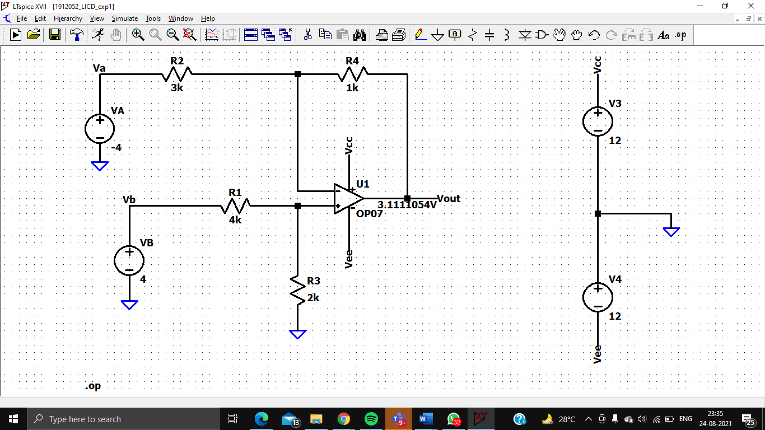

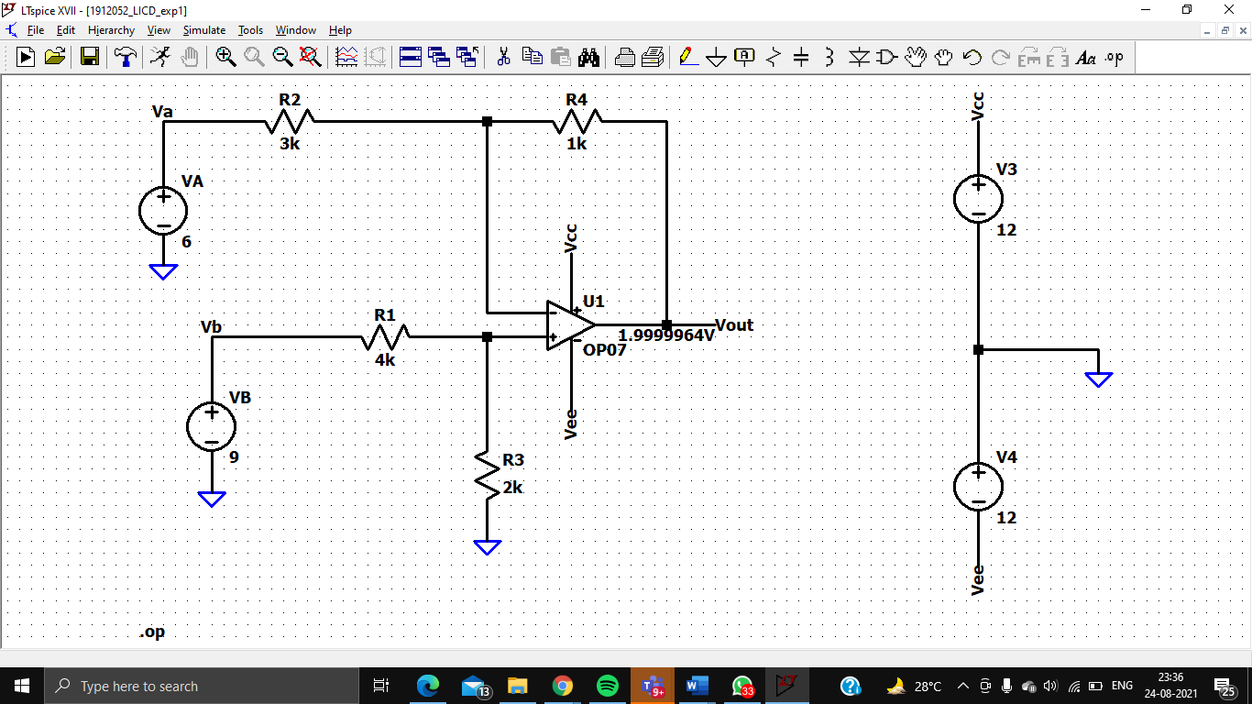

**Calculationsss**

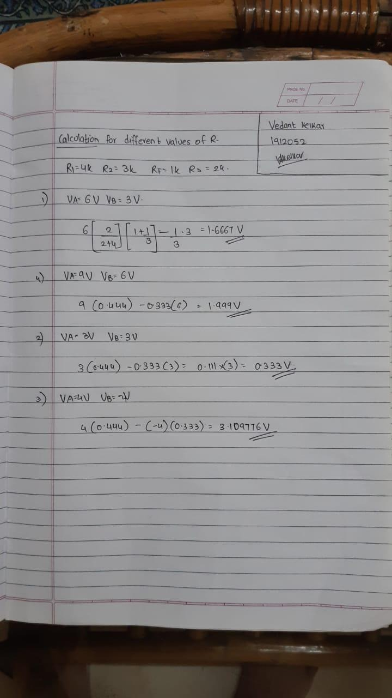

|  |
| --- |
| **Post Lab Questions:** |
| 1. List of all linear applications of op-amp.   Ans:   1. Sign changer, scale changer, inverting, and non-inverting amplifier. 2. Integrator, differentiator, and its application in analog computer. 3. Current to voltage (C–V or C/V ) and voltage to frequency (*V*–*F* or V/F ) circuits. 4. Voltage to frequency (V–F or V/F ) and frequency to voltage (F–V or F/ V ) conversion circuits. 5. Different circuits using op amps are analysed with input and output signal waveforms. 6. Design averaging circuit for four DC inputs.     **V(vout_vedant): -11 voltage**   1. Design Adder-Subtractor circuit using opamp.       **V(vout_vedant): -8.99996 voltage** |

|  |
| --- |
| **Conclusion:** |
| Linear equations using IC 741 is successfully implemented.  Thus we have implemented linear equations such as subtractor, averaging circuit and adder-subtractor using Opamp and verified it with the given input signals. |

|  |
| --- |
| **Signature of faculty in-charge with Date:** |